**VAGRANT BOX AND SERVER CONFIGURATION**

**CREATING VAGRANT FILE:**

FIRST WE NEED TO CREATE A ***vagrantfile*** FILE TO CONFIGURE OUR TEMPLATE FOR A VAGRANT BOX, WE DO THIS RUNNING: ***vagrant init*** ONCE LOCATED IN OUR PROJECT FOLDER ON GIT BASH:

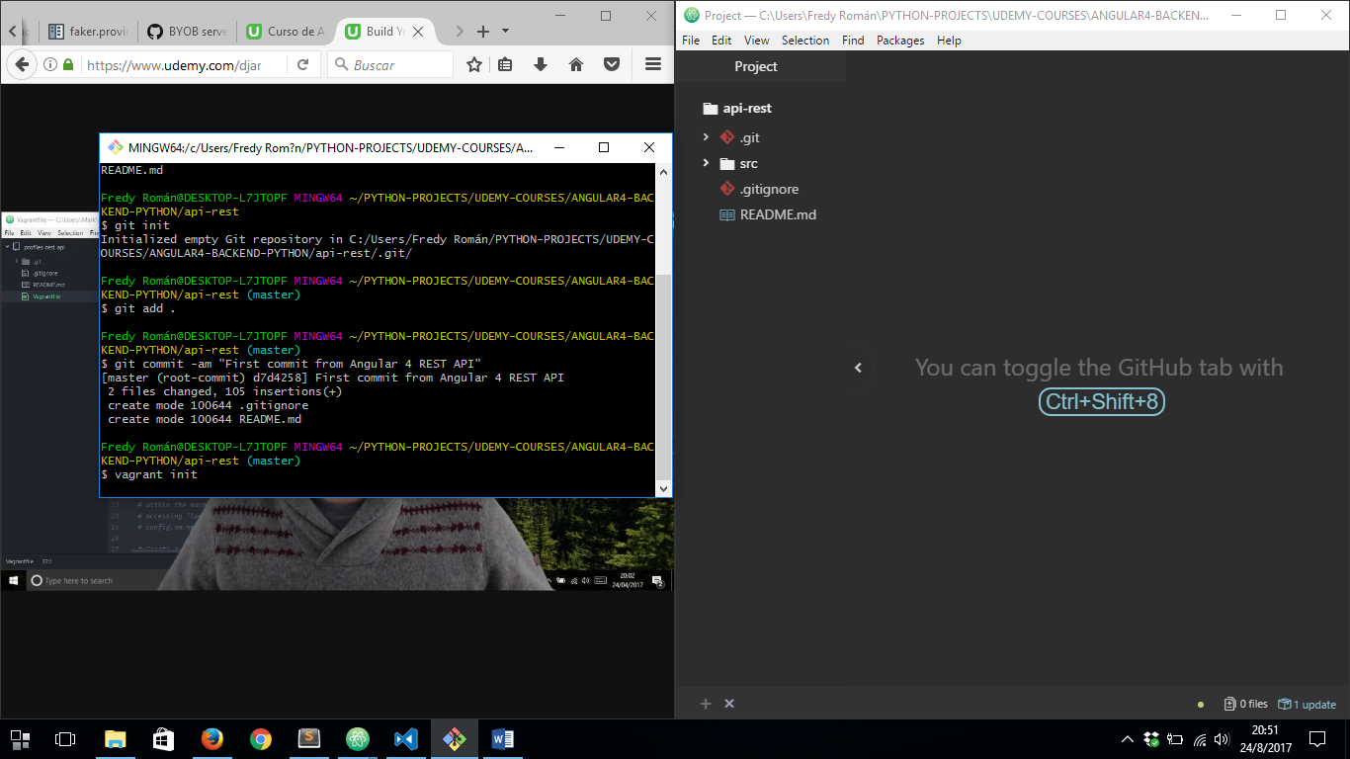

AFTER RUN THAT COMMAND VAGRANT WILL CREATE A VERY BASIC ***Vagrantfile*** AND THIS IS WHY WE NEED TO COPY CONTENT FROM THIS LINK:

<https://gist.github.com/LondonAppDev/d990ab5354673582c35df1ee277d6c24>

AND REPLACE THE CONTENT OF ***Vagrantfile*** WITH THAT CONTENT. NOW WE CAN SEE SOME LINES OF CODE IN THAT FILE TO CONFIGURE OUR SERVER:

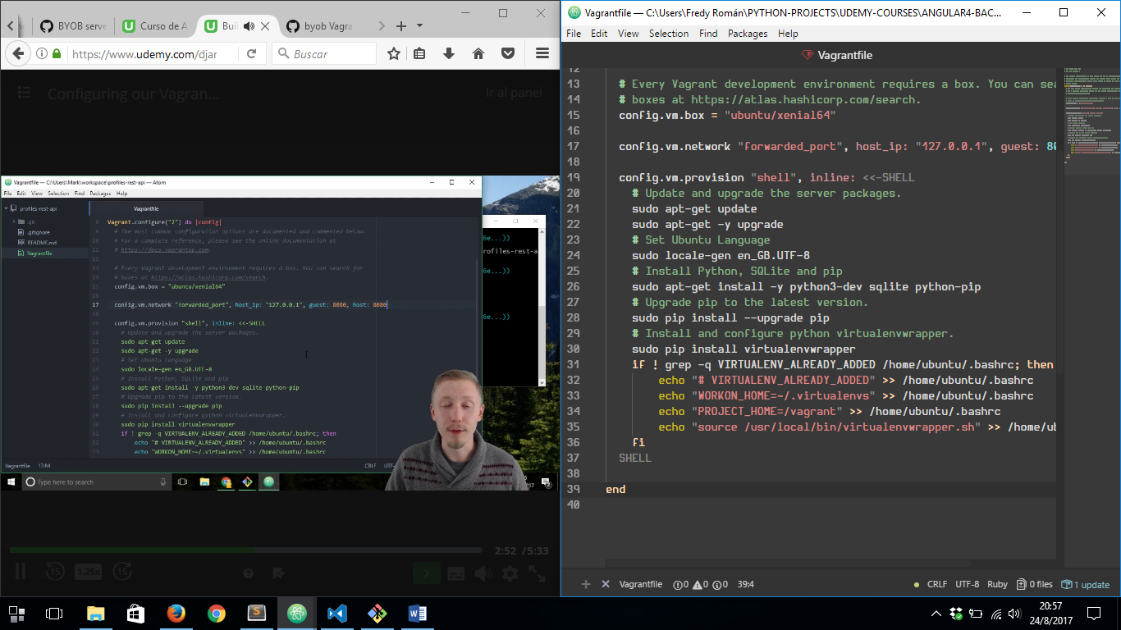

**CREATING OUR SERVER**

NOW ITS TIME TO CREATE OUR SERVER ONCE DEFINED ***Vagrantfile***, TO DO THIS WE HAVE TO RUN: ***vagrant up*** ON GIT BASH:

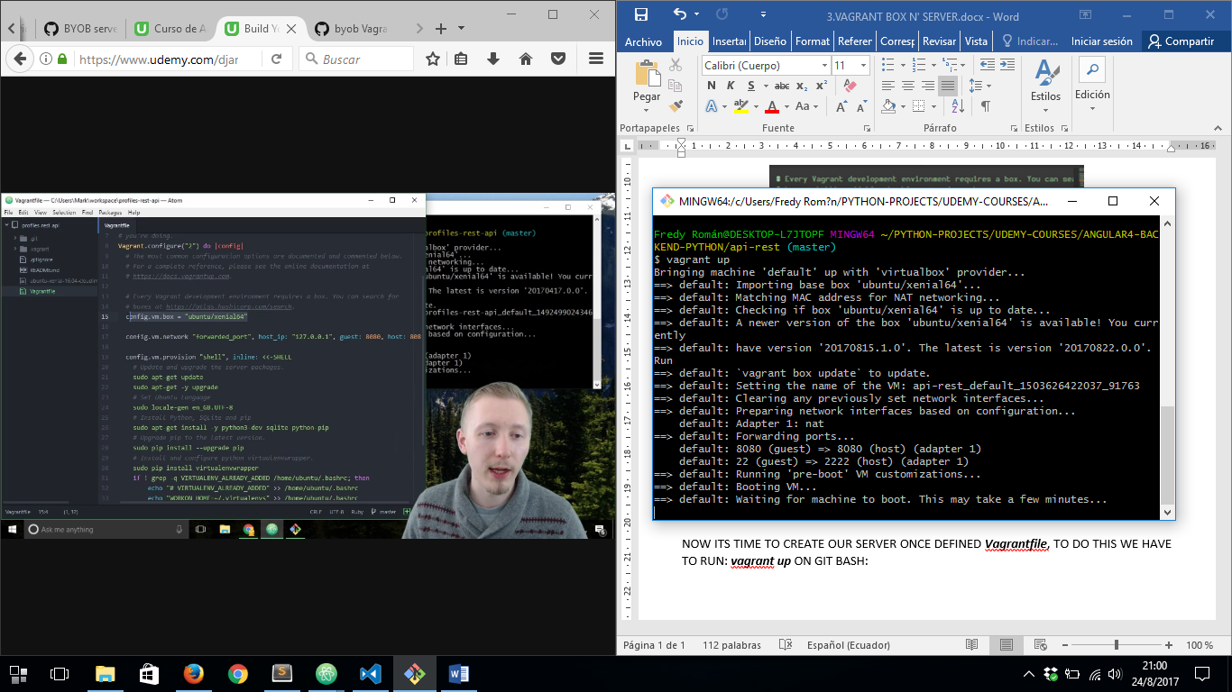

**NOTE:** IN CASE WE CATCH AN ERROR WHILE ***vagrant up*** COMMAD IS RUNNING WHICH REFERS TO “*INCOMPATIBLE WINDOWS CHARSET ENCODING*” OR SOMETHING LIKE THAT, WE HAVE TO ENSURE OUR VAGRANT HOME DIRECTORY HAS BEEN NAMED WITH NON SPECIAL CHARACTERS, SO TO RESOLVE THAT PROBLEM WE CHANGE VAGRANT HOME DIR RUNNING NEXT COMMAND ON WINDOWS PROMPT AND THEN RESTART WINDOWS:

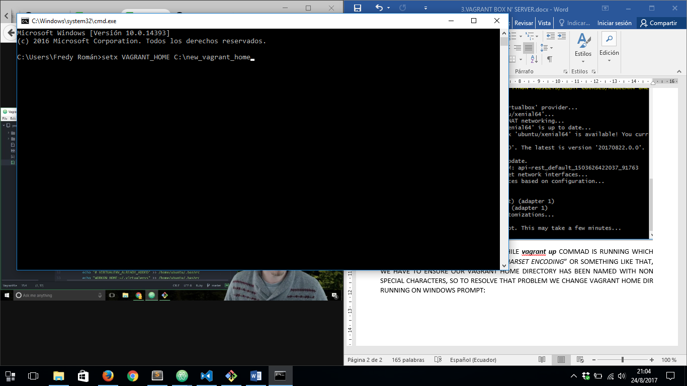

AFTER THAT WE’LL BE ABLE TO RUN ***vagrant up*** WITHANY PROBLEM.

IN CASE YOU STIL HAVING TROUBLES WITH SPECIAL CHARACTERS WITH VIRTUAL BOX VMs DIRECTORY IN THIS TIME, WE HAVE TO CHANGE THAT FOLDER TO OTHER LOCATION:

SO TO ACHIEVE THAT WE HAVE TO RUN VIRTUAL BOX AND OPEN PREFERENCES:

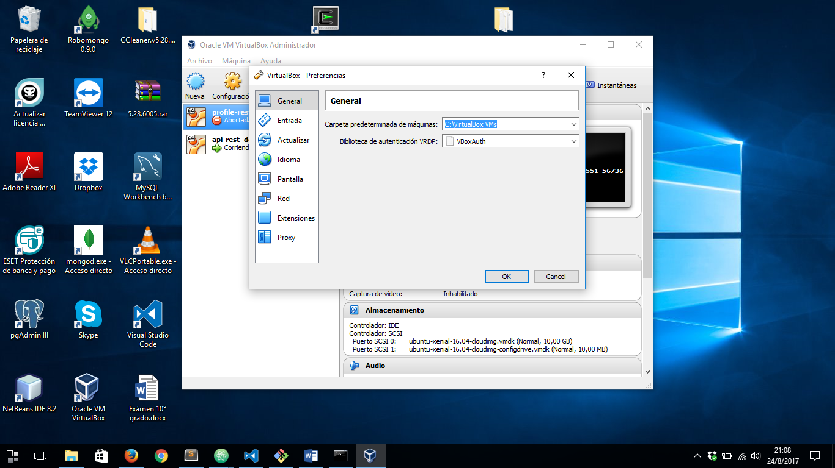

AFTER DO THIS WE’LL BE ABLE TO RUN ***vagrant up*** WITH ANY PROBLEM.

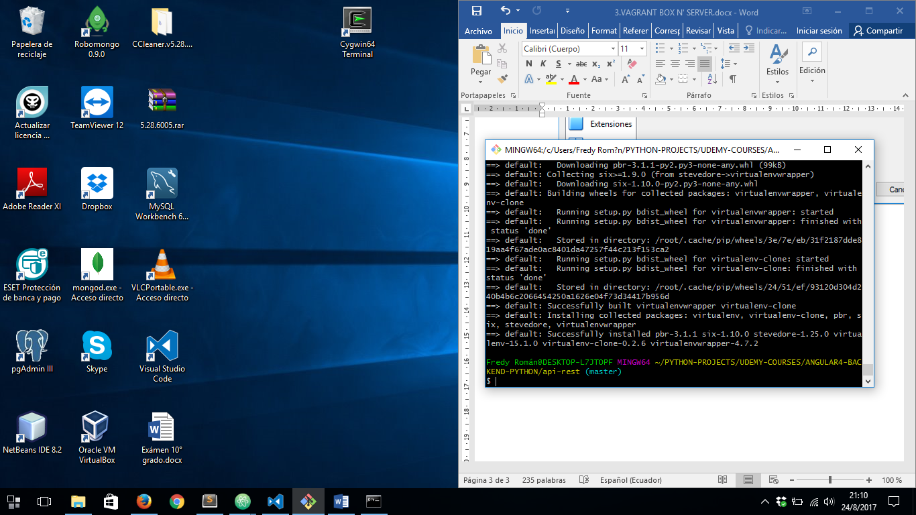

FIRST TIME WE RUN THAT COMMAND, VAGRANT WILL DOWNLOAD AND PREPARING OUR UBUNTO XENIAL SERVER:

**CONNECTING TO OUR VAGRANT UBUNTO SERVER**

TO DO THIS WE HAVE TU RUN ***vagrant ssh***

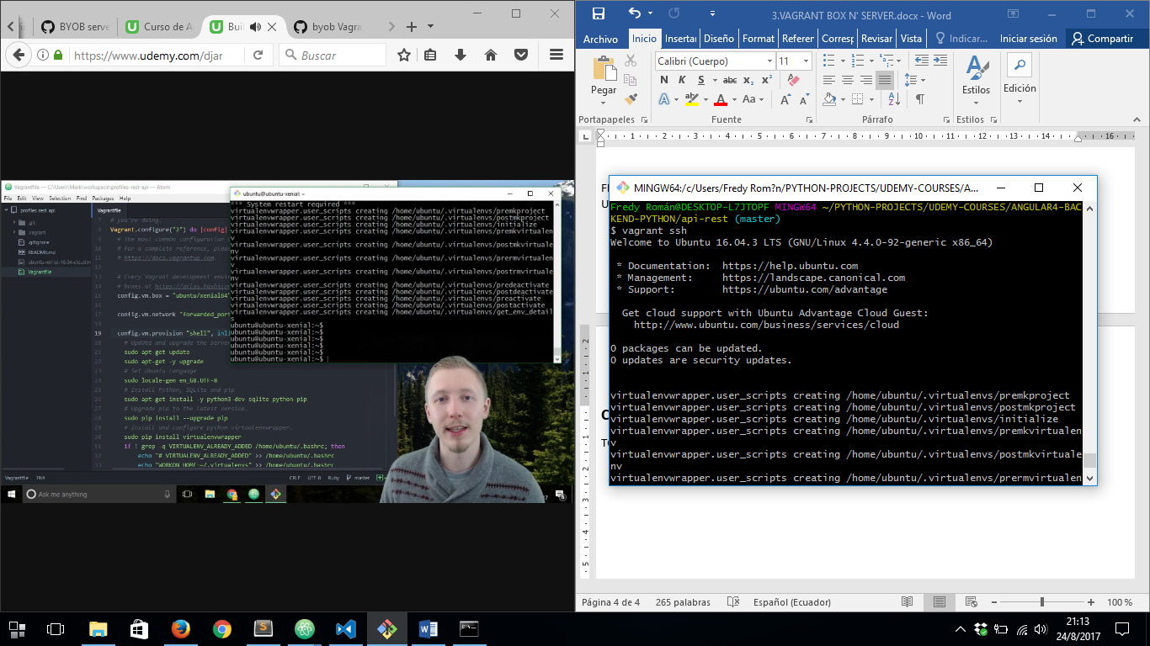

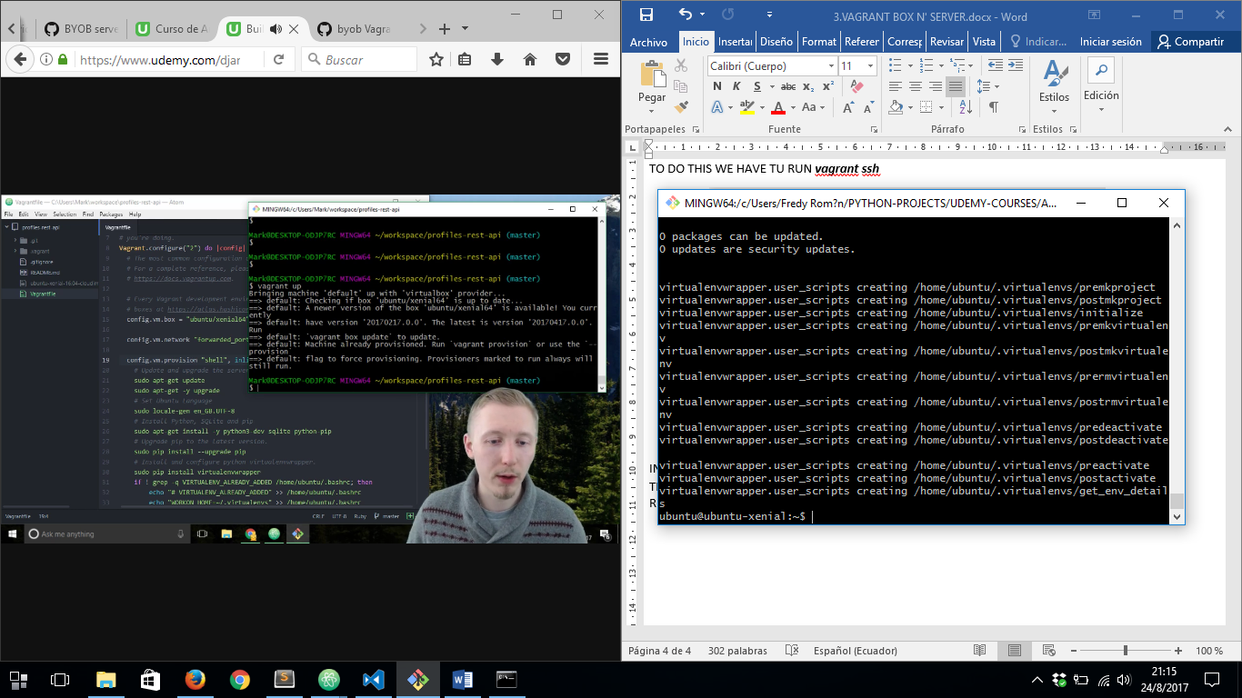

IN ORDER TO RUN AND CONNECT TO OUR SERVER AGAIN WE HAVE TO RUN ***vagrant up*** BUT THIS TIME IT ONLY WILL START OUR SERVER AND THEN WE WILL ABLE TO CONNECT TO IT RUNNING ***vagrant ssh***